Exercise no:11

Date:21.11.20

Aim:

To write a python program obtain greatest commom divisor (GCD) of given two numbers.

Program:

def gcd(a,b):

if(a==0):

return a

if(b==0):

return b

if(a==b):

return b

if(a>b):

return(gcd(a-b,b))

else:

return gcd(a,b-a)

a=int(input("Enter first number:"))

b=int(input("Enter second number:"))

GCD=gcd(a,b)

print("GCD is:")

print(GCD)

Link:

<http://103.53.53.18/mod/vpl/forms/edit.php?id=326&userid=1702>

Output:

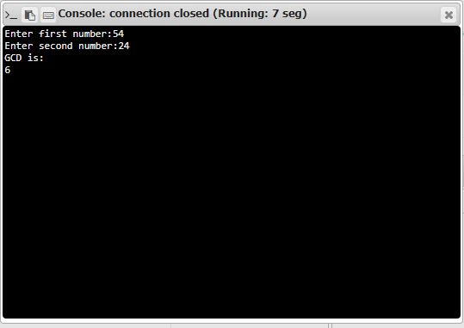

Result:

Thus the program has been successfully executed and the output is verified.